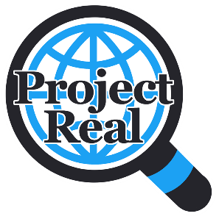

**Session 5: Fake Videos - Teacher Guide**

The materials for the session can be found on the Powerpoint (“Fake Videos”. The Powerpoint has notes which outline the content and other information which might be useful. The full session should take around 60 minutes to complete, but please feel free to be flexible on timings depending on student interest. You will need a projector to show the slides and to be able to play the videos. Videos are embedded, but the links to the original Youtube videos can also be found in the notes section in case of any issues. You do not need any special equipment for this session.

The content of this session should take around 30 minutes to complete, please spend the **final** 30 minutes of the lesson asking students to complete the post test questionnaire which is available on the following link:

<https://survey.eu.qualtrics.com/jfe/form/SV_3Ww2905HoYhvrPE>

Some of the questions will be similar to the questionnaire they completed at the first time point. Please encourage them to work through this on their own, and have an alternative, quiet activity for other pupils who do not have parental consent to complete the questionnaire.

The aims of this session are to teach students:

* Understand why people might make fake videos
* Explore how to check if videos are real
* Think about positive and negative use of fake videos

**PLAN FOR THE SESSION**

* The session starts with the SHARE guidelines. Please remind students of these from the last session.
* There is then a short starter where we ask pupils to discuss if they have seen any fake videos online and how they knew they were fake. This can be done as a small group or full class discussion. (5 minutes)
* There is then a short video where Dr Yvonne Skipper discusses fake videos, why people might make them, the pros and cons and some ideas of how to spot them (7 minutes).
* The main activity involves showing students different Youtube videos and asking them to discuss whether they think they are real and crucially why they think this. Different videos are embedded with discussion questions. After each example, we give a question slide and finally an answer slide which includes some points which the students could have discussed. This would work best as a small group discussion. (30 minutes)
* The final activity is a short quiz. You could ask students to put their hands up to give an answer, each correct answer wins a point for their team. (5/10 minutes)
* There is then a slide on how they can use the information they have learned in their other lessons. Please feel free to edit this so it fits with other curricula.

Please do let us know if you have any feedback on this session ([Yvonne.Skipper@glasgow.ac.uk](mailto:Yvonne.Skipper@glasgow.ac.uk)).